11.56: (a) and (b)

Lower rod:
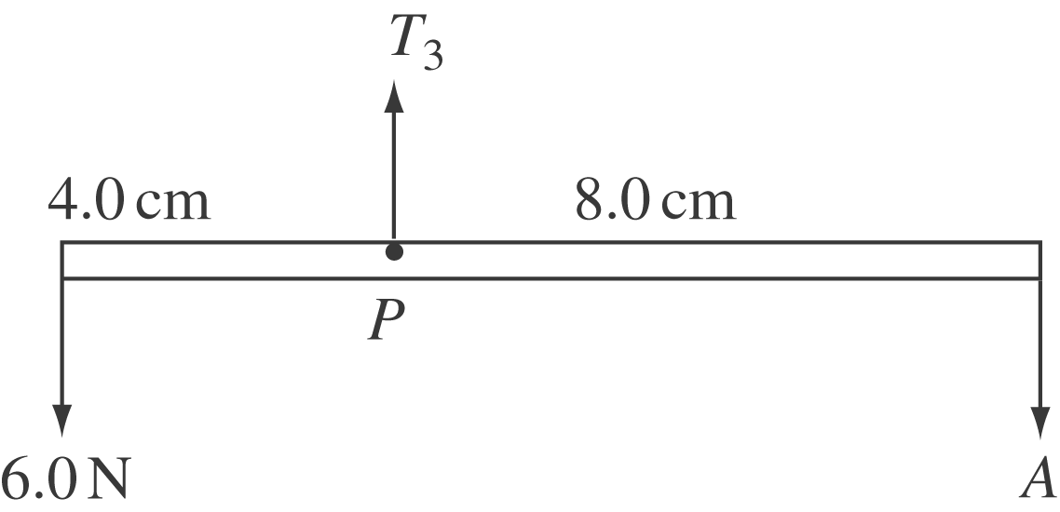

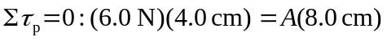
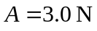

Middle rod:
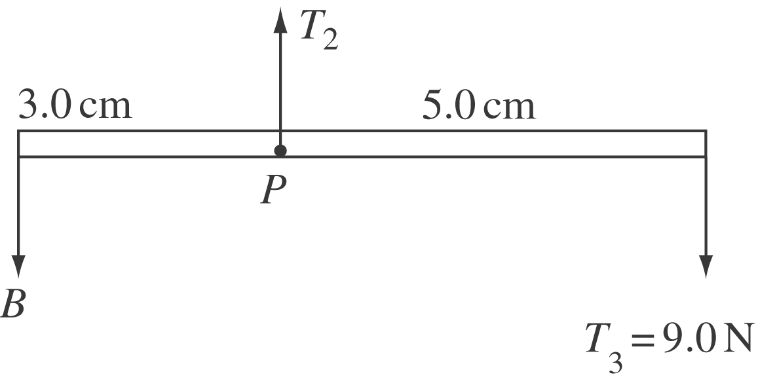
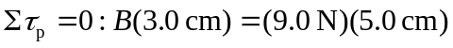
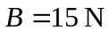

Upper rod:

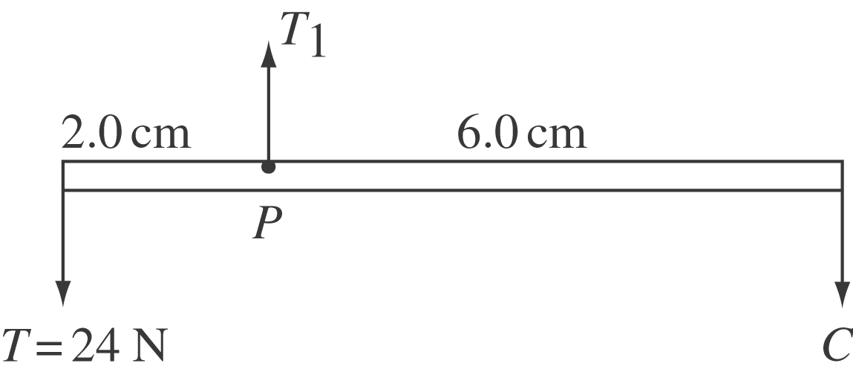

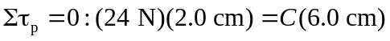
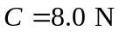

(c) The center of gravity must lie somewhere directly below  or the mobile would tilt.

